**PatchlinerAuto User Guide**

***Version 2.0***

*(MATLAB R2019a or later)*

**Ion Channels and Human Disease Laboratory,**

**Florey Institute of Neuroscience and Mental Health**

**11th of December, 2020**

**Created by Lauren Eldershaw**

Contents

Overview of PatchlinerAuto Analysis Workflow 4

Installing MATLAB for the first time 4

Running PatchlinerAuto 4

From File Explorer 4

From MATLAB 4

Input Settings & Graphing 6

Analysis Configuration – First Tab 6

Browse for Data File 6

Set Required Parameters 6

Load Settings from File (Optional) 7

Import Data 8

Wells – Second Tab 9

Graph – Third Tab 10

Setting the Time Intervals 10

Plotting the Graphs 11

Adjusting Time Intervals 11

Iterating through Plots 12

Save Settings to File 13

Reset Settings 14

Run Analysis 15

1. Rise time 15

2. Steady state current amplitude 15

3. Tail current 15

4. Conductance (optional) 16

Output Files 16

Execution Log 16

Troubleshooting Errors 17

PatchlinerAuto Error 17

MATLAB Error 17

**in the app.**

# Overview of PatchlinerAuto Analysis Workflow

The PatchlinerAuto Analysis Workflow was created to assist users in reviewing data output by the Patchliner system. The workflow allows the user to import data, select wells for analysis, view and exclude plots, and visually select time intervals to calculate rise times, steady state current amplitudes, tail currents and conductance for the plots.

# Installing MATLAB for the first time

This code is written and tested to be compatible with MATLAB Version R2019a. No additional toolboxes are required.

# Running PatchlinerAuto

Note: if you have downloaded the PatchlinerAuto files in a .zip file be sure to extract the files first before attempting to run PatchlinerAuto as to avoid an error message.

## From File Explorer

With MATLAB closed, navigate to the folder that the latest version of PatchlinerAuto is stored in and double click on PatchlinerAuto.mlapp to open PatchlinerAuto.

## From MATLAB

Open MATLAB – **version R2019a or later is required**.

Navigate to the folder that the latest version of PatchlinerAuto is stored in by clicking on the file path section as shown below:

Double click on the PatchlinerAuto folder to open it. **There is no need to add the files to the path as PatchlinerAuto will do this automatically.**

Right click on PatchlinerAuto.mlapp and select ‘Run’:

The PatchlinerAuto application will open up which requires the user to import their data file and change the necessary settings (as shown in the image below). See Input Settings & Graphing for further details on how to adjust these settings to run the analysis.

# Input Settings & Graphing

## Analysis Configuration – First Tab

### Browse for Data File

Under **Input Files**, the user can select the input data file to be imported. Clicking the ‘**Browse’** button brings up a dialog box for the user to select the data file to be imported. **The preferred file type is a .mat file**, converted from Patchliner’s .dat file using the HEKA program.

Correctly formatted spreadsheets in Comma Separated Values format (.csv) files are also accepted, however, large .csv files will likely take a long time to import and will cause MATLAB to freeze. An example csv file format can be found in PatchlinerAuto’s lib folder called *example_csv_format.csv*.

NOTE: the name of the input file will be used in the naming of all its output files.

### Set Required Parameters

The **Voltage Parameters**, measured in millivolts (mV), include the initial and end voltages of the recording and the number of voltage steps (sweeps per cell).

An option is provided to also **Calculate Conductance** during the analysis and create G/Gmax plots, using a given eK value.

**Other Parameters** include the **Current Scale** of the data with the option to scale the data in microamps, nanoamps or picoamps, and the **Rise Time Percentages**. The Rise Time Percentages are required to calculate the rise time of each recording in which the time taken for the signal to change from the low Sub value to the high Sup value is calculated. Commonly these values are 10% and 90% of the range of the signal, respectively (hence 0.1 and 0.9).

### Load Settings from File (Optional)

This is an optional step which allows the user to load settings previously saved to a file, otherwise the default settings are used (DefaultSettings.mat). Clicking the ‘**Browse and Load’** button brings up a dialog box which asks the user to select a previously saved MATLAB file (.mat) containing settings to be imported and a loading screen will show until the settings have been loaded.

The settings loaded include the voltage parameters, current scale and rise time percentages on the Analysis Configuration tab and the time intervals on the Graph tab.

The **Current Settings File** label allows the user to see what settings file was last loaded into PatchlinerAuto, however, parameters may have been manually changed since the file was imported. Clicking the red ‘**Reset’** button in the bottom-left corner of the window resets the PatchlinerAuto window and reloads the input settings from the Current Settings File.

For information on what settings can be saved and how to save settings to a file see Save Settings to File.

### Import Data

To import the data file, click the ‘**Import Data**’ button and a loading screen will then appear while the data is being imported.

##### MATLAB File (.mat)

If a .mat file has been selected to be imported then an **Import .mat File** dialog box will appear. The user will be required to select the wells that were successfully recorded, and input the number of sweeps performed per well, the number of applied pharmacology runs (iters) and select whether a test pulse was performed.

## Wells – Second Tab

The **Wells Tab** allows the user to select the wells from the 8-well plate to be analysed. Importing a data file results in the wells not found in the data to be greyed out, leaving only those in the data file to select from. All wells can be selected or cleared using the ‘Select All’ and ‘Clear All’ buttons.

**NOTE: At least one well must be selected for data to be plotted in the Graph Tab and each well may have multiple recordings which are shown as separate graphs.**

## Graph – Third Tab

### Setting the Time Intervals

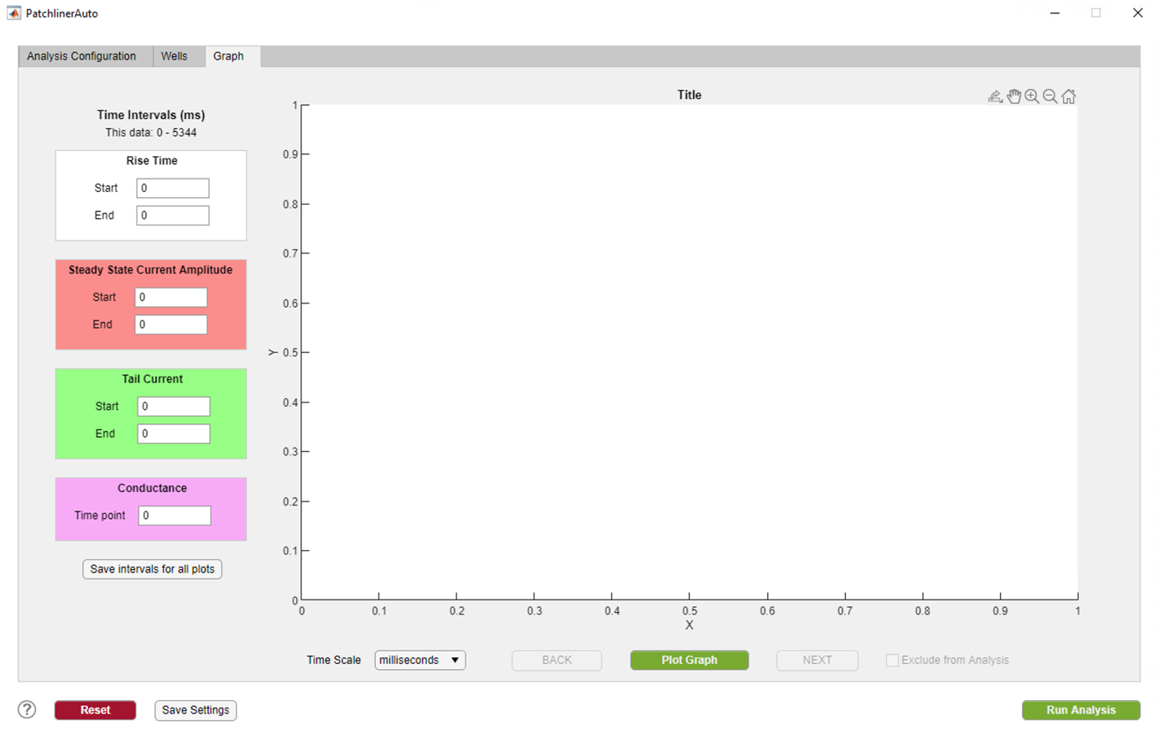

The label **This data** gives the time interval of the imported data in milliseconds (ms) to help the user specify valid time intervals for calculating the rise time, steady state current amplitude, tail current and conductance (optional) of each plot.

The time intervals for which to calculate the **Rise Time**, **Steady State Current Amplitude and Tail Current** of the plots can be specified according to their start and end times in their respective colour-coded panels.

The time point for which to calculate the **Conductance (optional)** of the plots can be specified in the additional colour-coded panel, when **‘Calculate Conductance’** is selected on the Analysis Configuration Tab.

The interval/time point values entered for the current plot can be saved for all plots in the set by clicking the **‘Save intervals for all plots’** button.

### Plotting the Graphs



**3**

**1**

**2**

The **Time Scale** (1)for the graph can be set to milliseconds or seconds, and this option will also change the time scale for the graphs saved to file when the analysis is run.

Click the **‘Plot Graph’** (2) button to plot the data for the selected wells and add the bounds of the specified time intervals in their respective colours. The graphs can be zoomed in and out by scrolling or by using the set of tools that appear in the top-right of the graph window (3) when hovering the window. Clicking the  button in this set of tools also zooms out the graph and brings it back to centre.

### Adjusting Time Intervals

The **Rise Time** interval is shown by a black box and its start and end times should be lined up with the start and end of the current.

The **Steady State Current Amplitude** interval is shown by a red box and its start and end times should be positioned such that it encompasses the time window where the current has reached equilibrium. This is generally a time window at the end of the current .

The **Tail Current** interval is shown by a green box and its start and end times should be positioned such that it encompasses the time window just following the peak current.

The **Conductance** time point is shown by a pink vertical line and should be positioned such that the current for each voltage at this point will be used in the conductance calculation.

Note: The **height of the boxes** suggest the maximum and minimum current within that time interval. Hence, the boxes should tightly bind the data points to be analysed, otherwise an artefact peak has been included in the selected time interval and the interval should be adjusted.

### Iterating through Plots

Iterate through the plots by clicking the **BACK** and **NEXT** buttons or by using the left and right keyboard arrows. Using these buttons or the arrows saves the settings for the current plot, loads the settings for the next plot and graphs the next plot with the appropriate interval bounds.

An **‘Exclude from Analysis’** checkbox is available for each plot which if checked excludes the plot from being included in the Run Analysis step.

The plots are labelled sequentially starting from ‘Figure 1’ and also include the well and pharmacology iteration (eg. Figure 1 – Well_1_Pharm_2).

# Save Settings to File

The current input settings can be saved to a file by clicking the **‘Save Settings’** button. The settings saved include the voltage parameters, current scale, conductance selection and eK value, and rise time percentages on the Analysis Configuration tab, and the time intervals for the current graph on the Graph tab.

Clicking the ‘Save Settings’ button opens up a dialog box for the user to select the location to save this file, where the default is PatchlinerAuto’s lib folder.

For further information on how to load a settings file into PatchlinerAuto see Load Settings from File.

# Reset Settings

Clicking the red ‘**Reset’** button in the bottom-left corner of the window resets the PatchlinerAuto window and reloads the input settings from the Current Settings File.

For information on the Current Settings File see Load Settings from File.

# Run Analysis

Click the green **‘Run Analysis**’ button to perform the analysis steps for the plots selected. A dialog box will pop up asking the user to select the folder to save the output files to and a loading screen will show until the analysis has concluded and the files have been created.

The analysis steps include saving each plot to a **.jpg** file and calculating the rise time, steady state current amplitude and tail current for every interval in the plots.

## 1. Rise time

Rise time is the time taken for the signal to change from a selected low value to a selected high value. Commonly these values are 10% and 90% of the range of the signal respectively.

Rise time is calculated by first calculating the range of the **Rise Time** interval selected and then by identifying the time between when 10% and 90% of the range are reached.

## 2. Steady state current amplitude

The steady state current amplitude is calculated by averaging all the datapoints within the **Steady State Current Amplitude** time interval.

## 3. Tail current

The tail current is calculated by averaging all the datapoints within the **Tail Current** time interval.

## 4. Conductance (optional)

The conductance is calculated using the current at each voltage at the **Conductance** time point specified. This calculation incorporates a reversal potential for potassium (eK) value and is normalised to G/Gmax, where Gmax is the maximum conductance across all voltages in the plot. Formula used is:

# Output Files

Each time the analysis is run a new folder is created in the output folder to hold the output files. These folders are named according to the date and time at which the analysis was run. For instance, the folder titled **‘2020-04-15 12.30.00 PM PatchlinerAuto’** contains the files from a PatchlinerAuto analysis run on the 15th of April, 2020 at 12:30 PM.

The **plot figures** are labelled sequentially starting from ‘Figure 1’ and also include the well and pharmacology iteration (eg. Figure 1 – Well_1_Pharm_2).

The parameters calculated are saved to separate Excel files (.xlsx) named the same as the input file with the respective suffixes of ***_rise*** for rise times, ***_steady*** for steady state current amplitudes, **­*_tail*** for tail currents, and ***_conductance*** for conductances. In the output files, the first row provides a label for each column according to the well label and the subsequent rows contain the values for each line/voltage in the plot.

The **additional conductance figures** are labelled sequentially starting from ‘Conductance Figure 1’ and also include the well and pharmacology iteration (eg. Conductance Figure 1 – Well_1_Pharm_2).

An additional Comma Separated Values file (.csv) is output if the data file imported was a MATLAB file (.mat). The file has the suffix _***imported*** and contains the formatted raw data retrieved from the .mat file.

## Execution Log

The **execution_log.xlsx** file is generated and saved with the output files to provide details about the data analysed and the input settings that were used in the analysis.

It provides the:

* Output folder
* Data file (if .mat file, includes the settings entered to import the file)
* Settings file
* Voltage parameters (start, end and number of steps)
* Current scale
* Conductance calculation (true/false) (if true, includes the eK value)
* Rise time percentages (Sub and Sup)
* Number of plots
* List of plots included and their respective time intervals
* List of plots excluded

# Troubleshooting Errors

## PatchlinerAuto Error

**"ERROR: Start and end of time intervals in settings file {filename} are not numbers within the specified limits."**

This error occurs when the time intervals in the Graph tab are not within the time range of the imported data. The wrong settings file may have been loaded or the time intervals in the Graph tab may have been manually changed.

**“ERROR: Cannot find start time {time} in time column of data.”** or **“ERROR: Cannot find end time {time} in time column of data.”**

This error occurs when a start or end time entered for one of the time intervals is not present in the data file. This error commonly occurs if the value entered has a decimal point but the times recorded in the data file are all integers.

**“ERROR: All plots have been excluded.”**

This error occurs when all plots have been excluded from the analysis step by ticking the ‘Exclude from Analysis’ checkbox for each plot on the Graph tab.

**“ERROR: The file type {filetype} is invalid. Valid file types are '.mat' or '.csv'.”**

This error occurs when the file type of the file selected is not either '.mat' or '.csv'.

## MATLAB Error

**"Error using PatchlinerAuto/saveState (line 264)**

**Cannot find 'lib' folder. FIX: check that files have been extracted from .zip file and that MATLAB is open to the correct Current Folder."**

This error occurs when MATLAB cannot find PatchlinerAuto’s lib folder. This commonly occurs if the folder containing PatchlinerAuto is a .zip file that has not been extracted, or if MATLAB is not open to the correct Current Folder